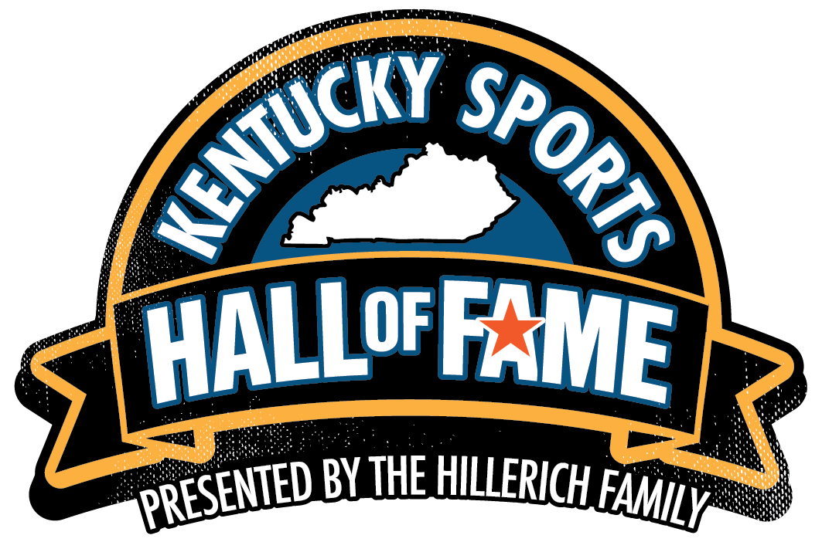
FOR IMMEDIATE RELEASE

Contact:
Lisa Mills
Louisville Sports Commission
502-689-2976
lmills@louisvillesports.org

Four Kentucky Natives named to Kentucky Sports Hall of Fame Class of 2026
Selections Represent Baseball, Basketball, Basketball Officiating and Track & Field

Louisville, Ky. – August 6, 2026 – Four native Kentuckians who have made significant contributions to sports in the Commonwealth, nationally and on the world stage, have been selected for the Kentucky Sports Hall of Fame (KSHOF) Class of 2026.

The 49th KSHOF class is comprised of Lexington native Tyson Gay, a world-class sprinter who still holds the American record in the 100-meter dash with the third-fastest time ever; Lebanon native Lisa Mattingly, one of the most highly accomplished basketball officials ever at both the collegiate and professional levels; Louisville native Rajon Rondo, a brilliant point guard at Kentucky and four-time NBA All-Star and two-time NBA champion; and Ashland native Brandon Webb, a fearsome pitcher in high school, college and the pros and National League Cy Young Award winner.

A selection committee comprised of 15 sports media professionals from throughout the Commonwealth chose this year’s class. All votes by the KSHOF Selection Committee were independently tabulated by regional accounting firm Dean Dorton, one of Kentucky's largest accounting and advisory firms, with offices in Louisville, Lexington and Raleigh, N.C.

The members of the 2026 KSHOF and their families will be honored on October 29 in iconic Freedom Hall in Louisville. For ticket information or sponsorship opportunities, contact Julie Howell at jhowell@louisvillesports.org / (502) 376-6450.

"The Kentucky Sports Hall of Fame Class of 2026 reflects excellence across multiple generations of Kentucky sports," said Louisville Sports Commission President and CEO Greg Fante. "Each inductee reached the highest levels of competition in their sport while representing the Commonwealth with distinction. We are proud to honor their accomplishments and celebrate their lasting impact during this year's enshrinement ceremony at historic Freedom Hall."

“Our family is honored to support the Kentucky Sports Hall of Fame and celebrate this incredible class of sports legends,” said Andrew Clark sixth-generation Hillerich and board member. “At Hillerich & Bradsby, we've always believed that sports have the power to inspire young people, strengthen communities and create memories that last a lifetime. We're proud to help recognize Kentucky natives whose achievements will continue to inspire future generations.”

The KSHOF was founded in 1963 to honor athletes and sports figures who are Kentucky natives, as well as individuals who participated in their respective sport or made a significant impact in their sports-related field in Kentucky. Since 2018, the Louisville Sports Commission, a Kentucky-based non-profit whose mission is to attract, create, host and operate sporting events and activities that enhance the quality of life of the Commonwealth, has owned and operated the KSHOF.

The KSHOF Class of 2026:

Tyson Gay
Lexington native and Lafayette High School graduate Tyson Gay began his career by winning multiple Class 3A sprint championships and setting the KHSAA record in the 100-meter dash (10.46). He went on to become one of the world’s elite sprinters for nearly two decades, still holding the American record in the 100 meters (9.69) and formerly owning the world best in the 200 meters on a straightaway. Following high school, Gay’s attended Barton Junior College in Kansas, where he won the 2002 NCJAA 100-meter championship and was named Male Track Athlete of the year. Two years later, he won the 100-meter dash for Arkansas at the NCAA Championships and was a member of the Razorbacks 4x100-meter national championship relay team in 2004. After turning pro, Gay won three gold medals and one silver at the World Athletics Track & Field World Championships, was a multiple-time USA Track & Field national sprint champion and was a member of the U.S. Olympic Teams in 2008, 2012 and 2016. Gay set the American record of 9.69 seconds in the 100 meters in Shanghai in 2009, a mark that remains the third-fastest legal time in history. At the 2007 World Championships in Osaka, he became the second man in history to win gold medals in the 100-, 200- and 4x100-meter events. In 2018, Gay established the Tyson and Trinity Gay Invitational High School track meet in Lexington to support youth track and field development in the Commonwealth, and later created the Trinity Gay Foundation to inspire, educate and prepare young people to succeed in academics, athletics and everyday life. He also trains and coaches sprinters through his global online community, the Ultimate Athlete: Accelerator (skool.com, and his Tyson Gay Official Coaching platform

Lisa Mattingly
Lebanon native Lisa Mattingly, a standout basketball player at Marion County High School, began her career officiating youth games for Lexington Parks and Recreation in 1984–85, and went on to become one of the most accomplished women’s basketball officials in history. In 2023, she was inducted into the Women’s Basketball Hall of Fame. Mattingly worked seven years of high school ball in Kentucky, moved on to the Kentucky Intercollegiate Athletic Conference from 1986-1993, then made her debut as an NCAA Division I official in the OVC in 1990. She spent 38 years as an on-court official, averaging approximately 85 games per year while working in the SEC, Big Ten and ACC, as well as conference tournaments for the SEC, ACC, Big Ten, Big East, Big 12, Conference USA, OVC and Missouri Valley. She officiated 21 NCAA Regionals, 18 NCAA Final Fours and 10 NCAA Championships. Mattingly officiated the WNBA from its inception and worked the finals from 2000 through 2007. Currently serving as coordinator of officials for the SEC, Sun Belt, SWAC, Southland, OVC, SoCon, and ASUN Conferences and ESPN Rules Analyst for the women’s NCAA Tournament, she also was liaison to the NCAA Rules Committee for three years. In 2002, she earned the prestigious Naismith College Official of the Year Award that recognizes veteran college basketball officials for their character, integrity and contributions to the sport. She also dedicates significant time to training young officials at the Referee University.

Rajon Rondo
Louisville native Rajon Rondo first gained statewide recognition in 2003 when he earned All-State honors and was named Seventh Region Player of the Year at Eastern High School before embarking on a 16-year NBA career that included four All-Star selections and two NBA championships. Rondo played his high school senior season at Oak Hill Academy, where he averaged 21 points and 12 assists per game, then was a two-year star at the University of Kentucky. As a Wildcat, he earned All-SEC Freshman Team honors in 2005, set the UK single-season record for steals for a freshman with 87 and had at least one steal in every game. A fierce defender, stellar passer with a great shooting eye, Rondo was named Second Team All-SEC in 2006 and in 68 career games as a Wildcat, he averaged 9.6 points, 4.2 assists and 2.3 steals. After his sophomore season, Rondo was the 21st pick in the NBA Draft by the Phoenix Suns and was traded immediately to Boston. As a pro, he was a four-time NBA All-Star, three-time assist leader, four-time NBA All-Defensive Team and won NBA titles with the Celtics (2008) and the Lakers (2020). In 957 games in the NBA, Rondo averaged nearly a double-double with 9.8 points, 7.0 assists, 4.5 rebounds and 1.6 steals per game. He spent eight seasons with the Boston Celtics, three with the Los Angeles Lakers and also played for the Dallas Mavericks, Sacramento Kings, Chicago Bulls, New Orleans Pelicans, Atlanta Hawks, Los Angeles Clippers and Cleveland Cavaliers. A tireless participant in community outreach throughout his playing career, he established the Rajon Rondo Foundation to support youth in Louisville’s underserved neighborhoods by providing the resources they need to become productive, confident and socially responsible members of their communities.

Brandon Webb
Ashland native Brandon Webb was a baseball star at Paul Blazer High School and a three-year standout at the Kentucky who became one of the most feared right-handed pitchers in Major League Baseball from 2003-08. In high school during his junior and senior seasons, Webb forged a 12-2 record with 140 strikeouts in 97 innings and an ERA of 1.58. At Kentucky, he was a three-year starter, and as a junior in 2000, Webb was one of the most dominant pitchers in the SEC, posting a 7-3 record with 123 strikeouts in 112 innings. Following his junior season at Kentucky, Webb was an eighth-round selection by the Arizona Diamondbacks in the 2000 MLB Draft, made his major league debut with the Diamondbacks in 2003 and for the next six years terrorized batters with his sinking fastball until injury cut short his career in 2009. Webb won the National League Cy Young Award in 2006 after posting a 16-8 record with a 3.10 ERA. He also finished second in Cy Young Award voting in both 2007 and 2008. Over seven major league seasons, Webb compiled an 87-62 record with a 3.27 ERA and was selected to three consecutive All-Star Games (2006-08) by posting an 18-10 record, 3.07 ERA with 42 consecutive shutout innings. Off the field, Webb established Brandon Webb’s K Foundation in 2005 to improve the lives of chronically and critically ill children throughout Arizona by providing daily support and life-changing experiences.

###

ABOUT Louisville Sports Commission
The Louisville Sports Commission (LSC) is a Louisville, Kentucky-based 501(c)(3) organization whose mission is to create a legacy of economic and social vitality through sports. The organization attracts, creates, hosts and operates sporting events and programs that enhance Louisville’s reputation as a premier sports destination and inspire active lifestyles to improve the quality of life for community members of all ages. More information is available online at louisvillesports.org and www.facebook.com/louisvillesportscommission.

ABOUT Kentucky Sports Hall of Fame
The Kentucky Sports Hall of Fame (KSHOF) was founded in 1963 to recognize athletes and sports figures who were born in, or who made a significant impact in their respective sports-related field in, the Commonwealth of Kentucky. Each inductee is recognized with a bronze plaque showcased in the official enshrinement gallery located in iconic Freedom Hall at the Kentucky Exposition Center in Louisville, Ky. After a hiatus in the 1970s and 1980s, the KSHOF was reinstated. In 2018, the Louisville Sports Commission became the overseer and administrator for all aspects of the KSHOF.

