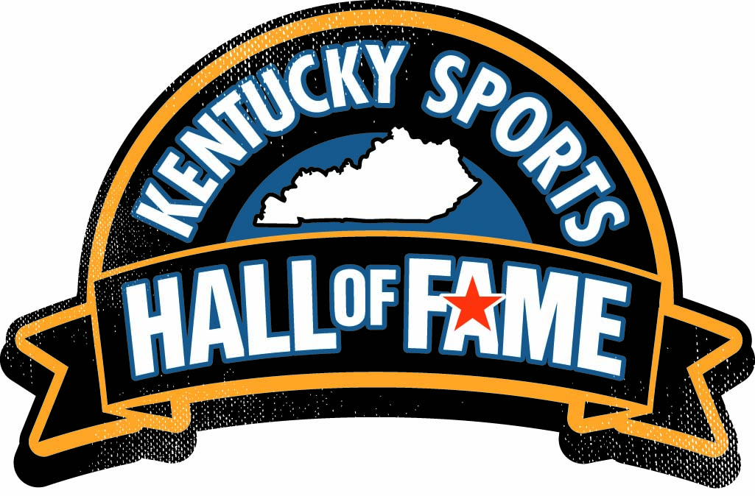**FOR IMMEDIATE RELEASE**

Contact:

Lisa Mills

Louisville Sports Commission

502-689-2976

lmills@louisvillesports.org

**Four Outstanding Individuals Selected to Kentucky Sports Hall of Fame Class of 2024**

***Selections Represent Basketball, Football and Media***

Louisville, Ky. – May 1, 2024 – Four individuals with strong Kentucky connections who have made outstanding contributions to sports in the Commonwealth and beyond have been selected for the Kentucky Sports Hall of Fame (KSHOF) Class of 2024.

The announcement was made today at a press briefing as part of Champions Day at Churchill Downs by the Louisville Sports Commission, the owners and operators of the KSHOF.

Comprising the 47th KSHOF class are **Teddy Bridgewater**, a dominant quarterback at the University of Louisville and first-round draft pick who played nine seasons in the NFL; **Tony Delk**, an All-American and NCAA Final Four MVP at the University of Kentucky who went on to a 10-year career in the NBA; **Oscar Combs**, who started covering University of Kentucky athletics at the Hazard Herald in 1965 and became an innovator in the coverage of major college athletics; and **Roy Pickerill**, who has been associated with the sports information office at Kentucky Wesleyan College for 53 years and was inducted into the CoSIDA Hall of Fame in 1999.

A selection committee comprised of 16 sports media professionals from throughout the Commonwealth chose this year’s class, along with the Bygone Era Selection Team. All votes by the KSHOF Selection Committee were independently tabulated by regional accounting firm Dean Dorton, one of Kentucky's largest accounting and advisory firms, with offices in Louisville, Lexington and Raleigh, N. C.

The 2024 KSHOF class members and their families will be honored in September 2024 in iconic Freedom Hall in Louisville. For ticket information or sponsorship opportunities, contact Julie Howell at jhowell@louisvillesports.org / (502) 587-6742.

"The KSHOF Class of 2024 recognizes four outstanding individuals who represent a broad spectrum of sports and occupations – individuals who had a major impact on sports in the Commonwealth and on the national stage," said Louisville Sports Commission President and CEO Greg Fante. “This year’s inductees have worked diligently to make a difference in their specific areas. And we are thrilled to honor them and their accomplishments in Freedom Hall, the KSHOF’s official enshrinement gallery.”

"It is with immense pride that we at Kentucky Venues, along with the passionate crowds at Churchill Downs and our colleagues at the Louisville Sports Commission, applaud the induction of four distinguished sports legends into the Kentucky Sports Hall of Fame. Their legacies will be enshrined within Freedom Hall, serving as a place of inspiration for generations of Kentuckians who will walk these grounds," said David S. Beck, President & CEO of Kentucky Venues.

The KSHOF was founded in 1963 to recognize athletes and sports figures who are Kentucky natives as well as individuals who participated in their respective sport or made a significant impact in their sports-related field in Kentucky. The Louisville Sports Commission, a Kentucky-based non-profit whose mission is to attract, create, host and operate sporting events and activities that enhance the quality of life of the Commonwealth, has owned and operated the KSHOF since 2018.

**The KSHOF Class of 2024:**

**Teddy Bridgewater**. Miami native Teddy Bridgewater was a dominant quarterback at the University of Louisville (UofL) who played nine seasons in the NFL. A three-year starter at UofL who threw for 9,817 career yards and 83 touchdowns, Bridgewater earned MVP honors leading the Cardinals to a 33-22 win over no. 2 Florida in the 2013 Allstate Sugar Bowl. The next season, he passed for 447 yards and three touchdowns in UofL’s Russell Athletic Bowl win over Miami. He was drafted in the first round by Minnesota and played nine seasons in the NFL with the Vikings, Saints, Panthers, Broncos, Dolphins and Lions. Bridgewater was named to the Pro Bowl in 2015; his career passing numbers are 15,120 yards, 75 touchdowns and 1,114 rushing yards.

**Oscar Combs**. Hazard native Oscar Combs started covering UK athletics at the Hazard Herald in 1965 and became an innovator in the coverage of major college athletics. In 1976, Combs founded the Cats’ Pause, the first independent publication to cover a major athletic program (UK) in the U.S., marking the start of a nationwide industry. For 20 years starting in 1998, he was co-host on the UK radio network pre-game coverage and helped to build and expand the Wildcats’ fan base in football and basketball. Combs has won numerous awards from the Kentucky Press Association and in 1977 won the U.S. Basketball Writers Association feature of the year. Combs was inducted into the Kentucky Journalism Hall of Fame in 2000.

**Tony Delk**. Brownsville, Tenn., native Tony Delk was an All-American and NCAA Final Four MVP at the University of Kentucky (UK) who went on to a 10-year career in the NBA. A sharpshooting guard, Delk led UK in scoring three seasons (1994-95-96), scored 1,890 points and still owns the school record for three-pointers (283) and is second in steals (201.). During his UK tenure, the Wildcats were 119-18, won three SEC Championships, went to two Final Fours and won the 1996 championship; Delk earned SEC Player of the Year in 1996 and was the 16th overall pick in the 1996 NBA draft by Charlotte. Delk played for eight teams, played in 545 games averaging 9.1 points, 2.5 rebounds and 1.9 assists in his career, and went to the playoffs seven times.

**Roy Pickerill.** Louisville native Roy Pickerill has been associated with the sports information office at Kentucky Wesleyan College for 53 years, starting as a student assistant, serving as the sports information director (SID) for nearly 30 years and currently serving in an emeritus role. Pickerill was inducted into the CoSIDA Hall-of-Fame in 1999, inducted into the Great Lakes Valley Conference Hall of Fame in 2008, earned CoSIDA’s lifetime achievement award in 2016 and his Kentucky Wesleyan publications earned 30 national awards, including 20 “Best in the Nation” awards. In 2022, the CoSIDA Division II SIDs created a distinguished service award in Pickerill’s name.

###

**ABOUT Louisville Sports Commission**

The Louisville Sports Commission (LSC) is a Louisville, Kentucky-based 501(c)(3) organization whose mission is to create a legacy of economic and social vitality through sports. The LSC attracts and hosts sporting events and activities that have a positive economic impact on Louisville, enhance the area's image as a premier sports destination and promote active lifestyles to improve the quality of life for community members of all ages. More information is available online at louisvillesports.org and www.facebook.com/louisvillesportscommission.

**ABOUT Kentucky Sports Hall of Fame**

The Kentucky Sports Hall of Fame (KSHOF) was founded in 1963 to recognize athletes and sports figures who were born in, or who made a significant impact in their respective sports-related field in, the Commonwealth of Kentucky. Each inductee is recognized with a bronze plaque showcased in the official enshrinement gallery located in iconic Freedom Hall at the Kentucky Exposition Center in Louisville, Ky. After a hiatus in the 1970s and 1980s, the KSHOF was reinstated. In 2018, the Louisville Sports Commission became the overseer and administrator for all aspects of the KSHOF.